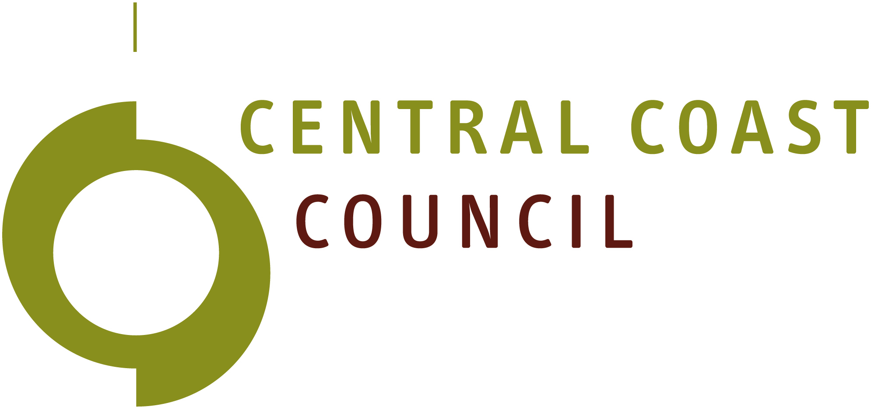

Disability Access and Inclusion Plan - Quick Read

What is this plan?
This plan explains how Central Coast Council will work to make our community more accessible and inclusive.
It looks at how we design our places, deliver services and communicate with the community, so everyone can take part.

Why is this important?
Some people face barriers that make it harder to access places, services and information.
We want to remove these barriers and make sure everyone feels welcome, included and able to participate in community life.

What has happened so far?
This plan builds on Council’s previous Disability Access and Inclusion Plan (2022–2025).
We have already made improvements to things like:
- public spaces and facilities
- communication and information
- how we engage with the community
This new plan continues that work and looks at what we can do next.

How was the plan developed?
The draft plan was developed with input from Council staff and the Disability Access and Inclusion Working Group. This means the plan is shaped by both lived experience and practical knowledge.

What does the plan focus on?

1. Inclusive placemaking
We will make our public spaces easier for everyone to use.
This includes:
- improving access to parks, buildings and facilities
- making footpaths and streets safer and easier to move around
- considering accessibility in new projects

2. Inclusive culture
We will build a more inclusive culture across Council and the community.
This includes:
- improving awareness and understanding of disability
- supporting inclusive attitudes and behaviours
- providing training and education for staff

3. Inclusive events, services and communication
We will make it easier for people to access Council services, information and community activities.
This includes:
- making events more accessible
- providing information in different formats
- using clear and simple language
- improving digital accessibility

How can you have your say?
We are now asking for community feedback on the draft plan.
We want to know:
- Does the plan focus on the right things?
- Is anything missing?
- What could be improved?
There are a lot of ways you can be involved.
Upload a voice response or complete an online survey:
https://my.centralcoast.tas.gov.au/disability-access-and-inclusion-plan
Attend a drop-in session:
Penguin Senior Citizens Club, 6th of May between 2pm and 7pm
Hive, Ulverstone, 7th of May between 10am and 4pm.
Contact us directly:
Call 6429 8900 or email traceyclark@centralcoast.tas.gov.au

Need help to participate?
If you need support or would like this information in a different format, please contact us with the details above. We can work with you to find a way to participate that suits your needs.

